**LAPORAN TEKS PROSEDUR**

**BAHASA INGGRIS**



Anggota Kelompok:

1. Abia Rofi Nugroho (1)
2. Dzaki Al Toriq (13)
3. Erick Ardiansyah (15)
4. Grivallent Verdiano Erlangga (17)

**How to use AssetFlow**

Goal: Teach peoples how to use AssetFlow website for manage inventory

Material: a Laptop or computer, an Internet

Steps:

1. First, Make sure your computer is on

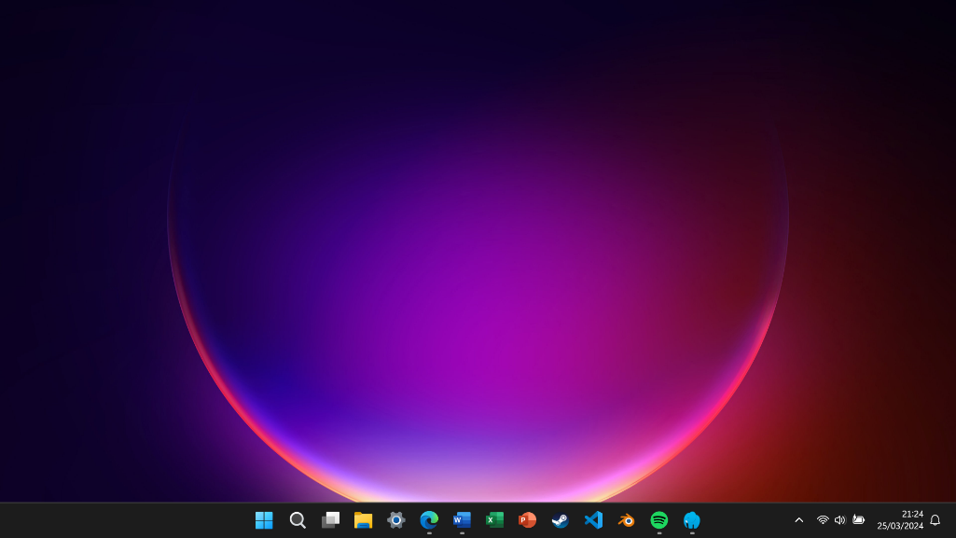

2. Second, Move your cursor to your browser and click it to open the browser

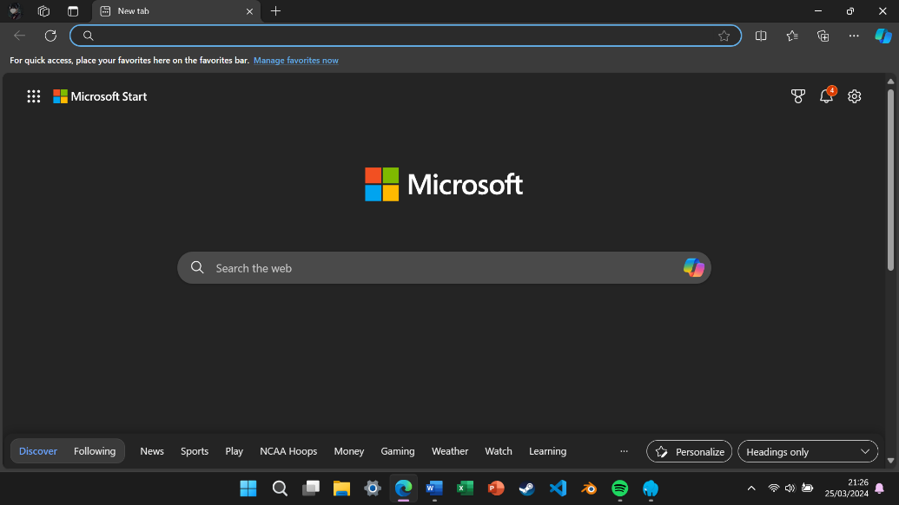

3. Third, Write the website address then click enter until it show login page

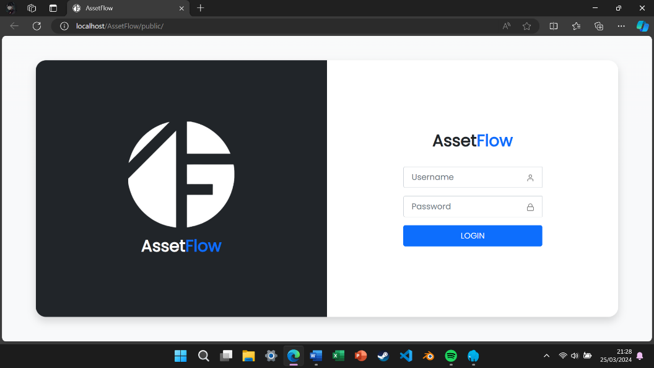

4. Fourth, enter username and password then click login

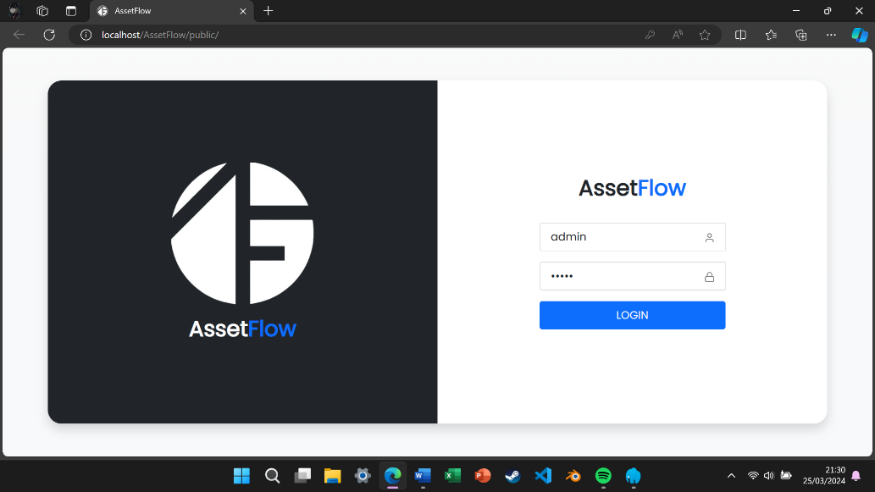

5. Fifth, Wait until it show dashboard page

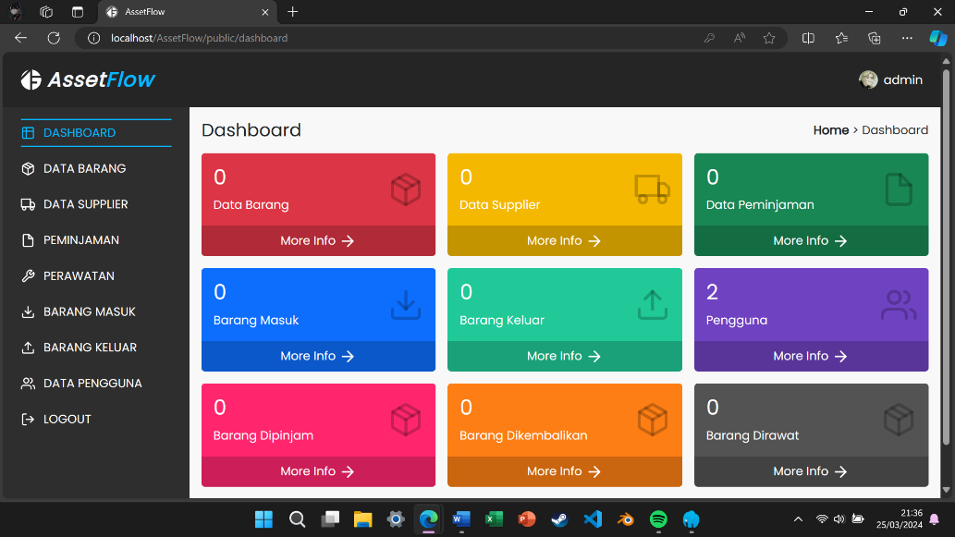

6. Sixth, Move your cursor to one of button on side bar and click it

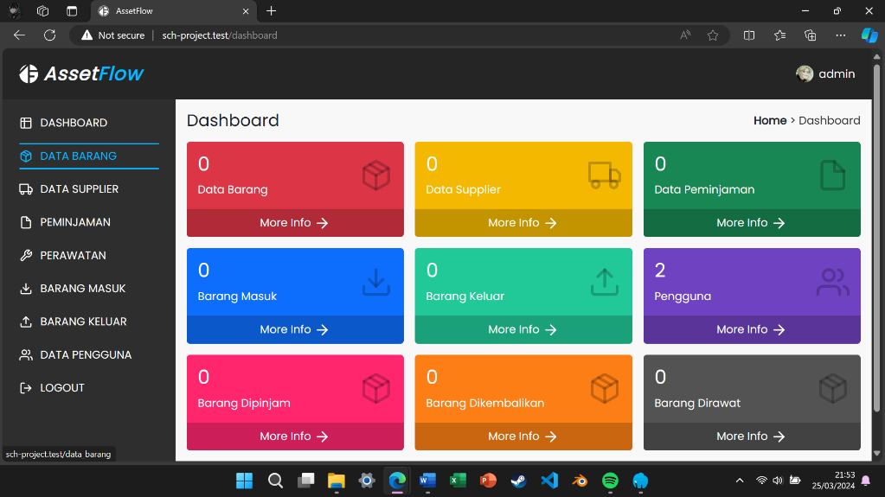

7. Seventh, Make sure it show Data Barang page

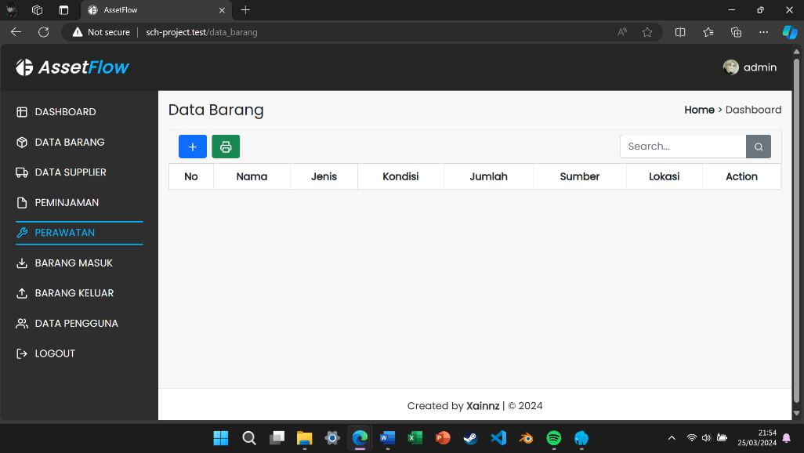

8. Eighth, Move your cursor to “+” logo and click it to add item

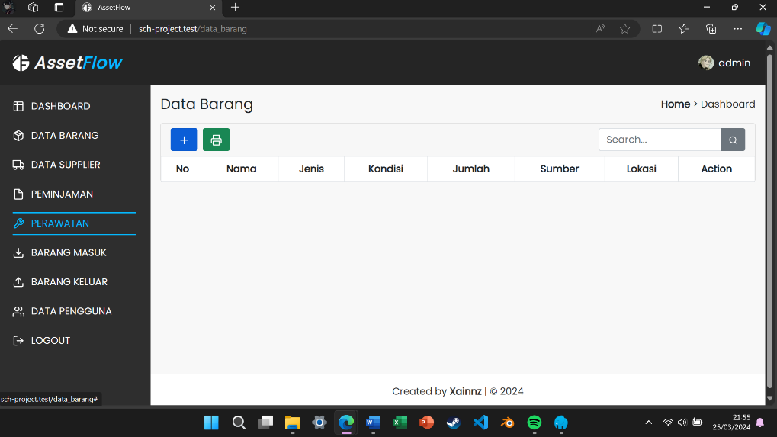

9. Ninth, Fill the form then click add

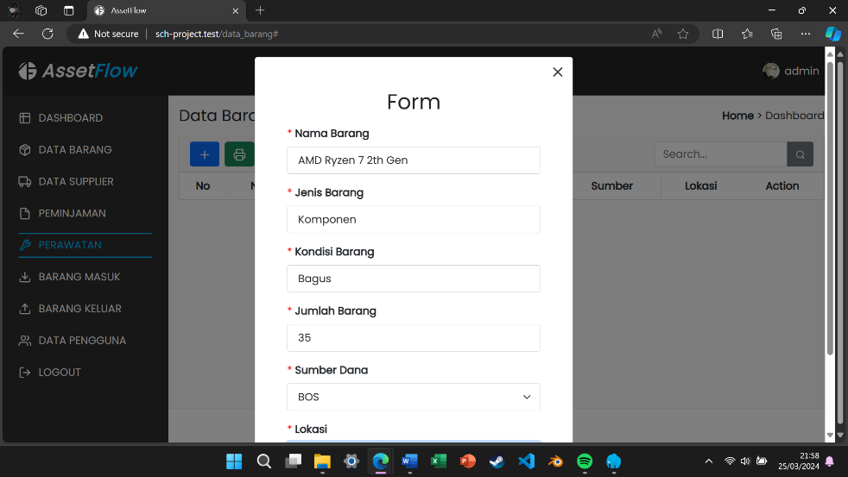

10. Tenth, The item is now show on the table then move your mouse to “edit” logo for edit the item details

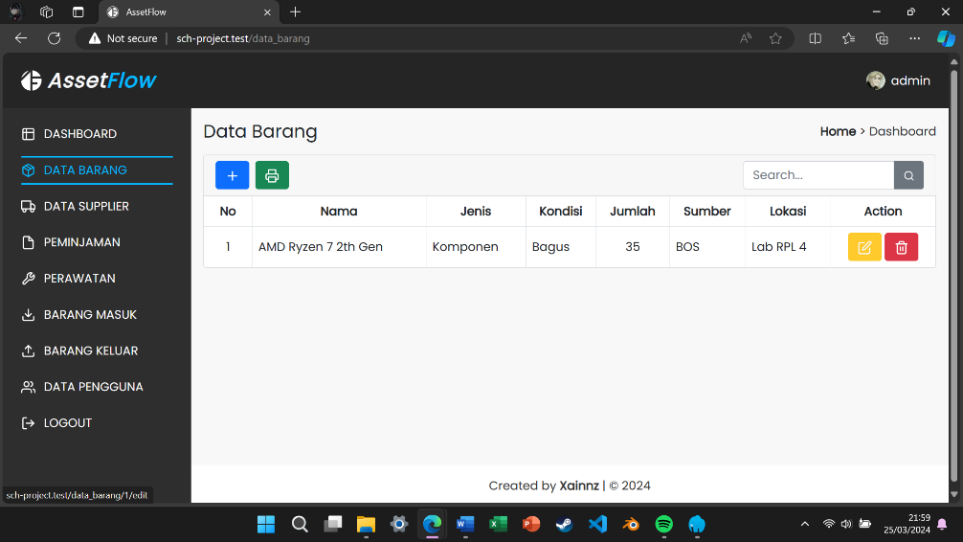

11. Eleventh, You can edit the details and save the changes

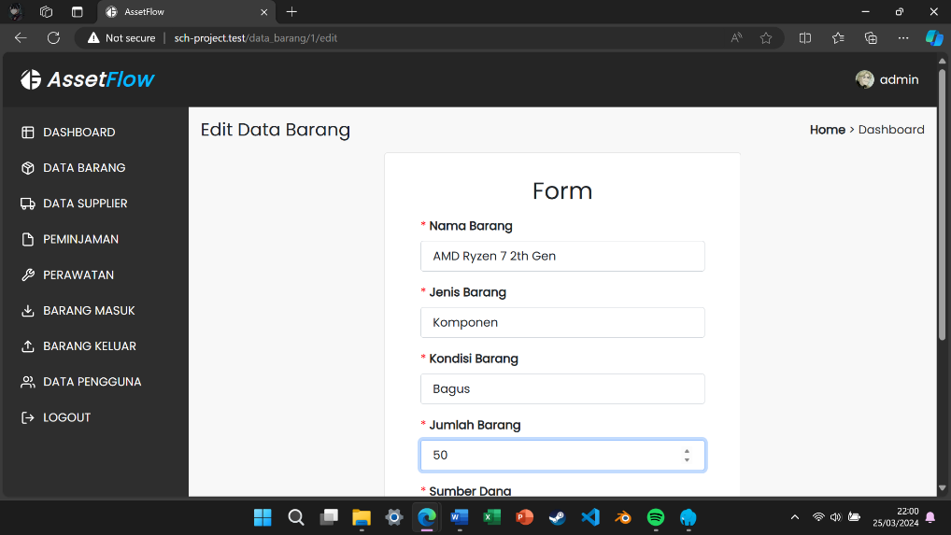

12. Twelfth, Move your cursor to “trash can” logo to delete the item

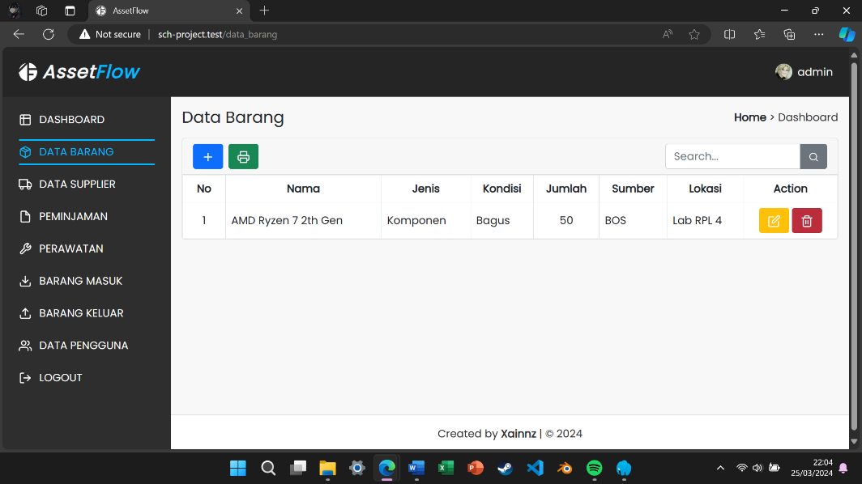

13. Finally, You can now use AssetFlow website for manage inventory. Congrats!